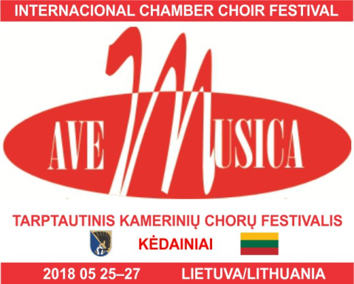

Festival Schedule

Friday 25/05/2018

Guests arrival, registration and accommodation allocation for your stay.
Arrival address for all guests is Kedainiai Cultural center, 24 Basanaviciaus street, Kedainiai, Lithuania.
Please let us know the time will you arrive by sending us an email to kulturoscentras.kedainiai@gmail.com. It would be great if you could come between 12.00 to 14.00 hours if possible.

19.00 h.Short concert to open the Festival (at Kedainiai Cultural center, 24 Basanaviciaus street, Kedainiai)
Chamber choir of Kedainiai Cultural Center will be perming at the beginning of the evening.
Each guest choir will have to perform 2 of their songs. There will be a piano on the stage, you will be able to sing a cappella, use piano or bring your own instruments. The choice is yours.
Dinner at a place of your stay.

Saturday 26/05/2018

Breakfast, tour guided trip, free time, lunch
16.00 h.Main festival's concert called 'Friends to friends'.
Location: Evangelical Reformed Church, (1Senoji street, Kėdainiai)
Each choir is given to perform up to a maximum of 30min (strictly) and each choir is free to choose their own repertoire. There will be a piano available to use on the stage.

20.00 h.Thank you dinner and party for all guests.
Sunday 27/05/2018

Breakfast.Choirs will be performing in various churches of Kedainiai.
Choirs will be leaving Kedainiai just after lunch time.

Thanks again for your interest to participate and we look forward to your reply.
You will receive a more detailed information later in the year.
See you soon in Kedainiai, a geographical centre of Lithuania!

